Virtual Art Gallery App

Project Setup:
1. Navigate to - https://github.com/Ayeshaq09/Unified-mentor-projects You will see all 8 projects.
2. To get the projects onto your system: click on "Code" button and copy the link - https://github.com/Ayeshaq09/Unified-mentor-projects.git
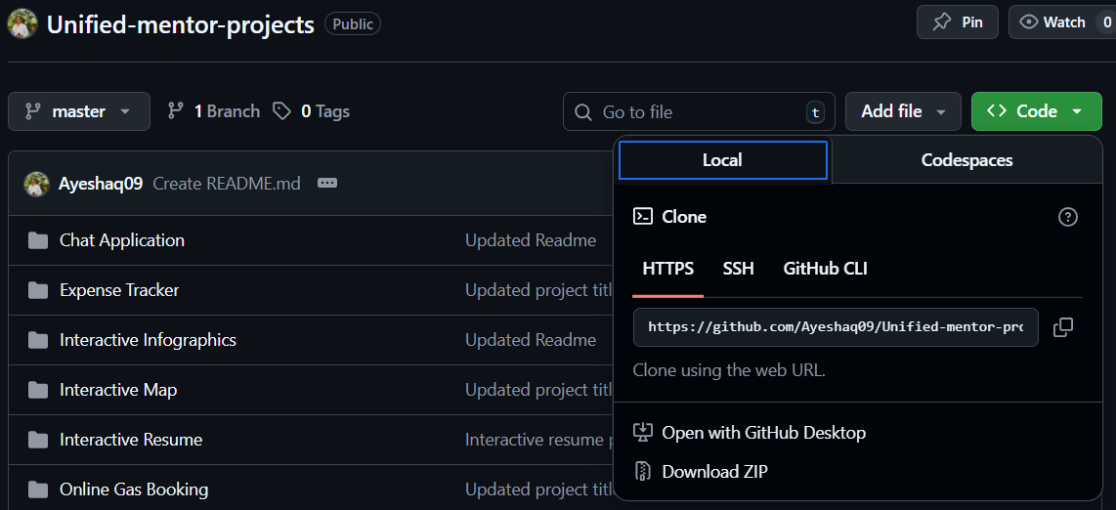
3. Open git bash and run the following command:
git clone https://github.com/Ayeshaq09/Unified-mentor-projects.git
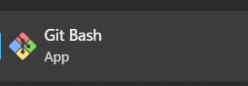
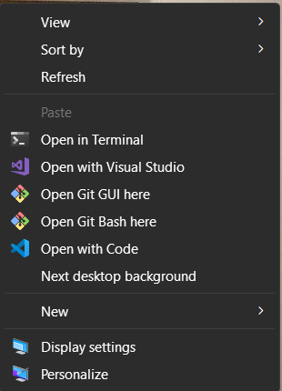
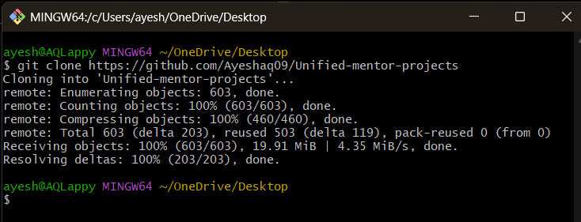
4. Once cloning is done, you get all the 8 projects onto your system.

About the project:
This project displays Indian cultural images in a 3D image carousel that contains modern animations and interactive effects.

Features
This application contains:
- 3D carousel
- Indian cultural images
- Sound effects
- Animations
- Modal to view image details
- Modal for zoom image functionality

The app is mobile-responsive and is user-friendly.

Technologies Used
- HTML5, CSS3, JavaScript, Reactjs
- react-tooltip for tooltips

Virtual Art Gallery project setup:
- Open the folder in vscode and in terminal run – npm install

- Then run –npm start

Functionality of the project:
- The application first displays a button to open the image gallery.
- On clicking the button, a 3D image carousel is displayed.

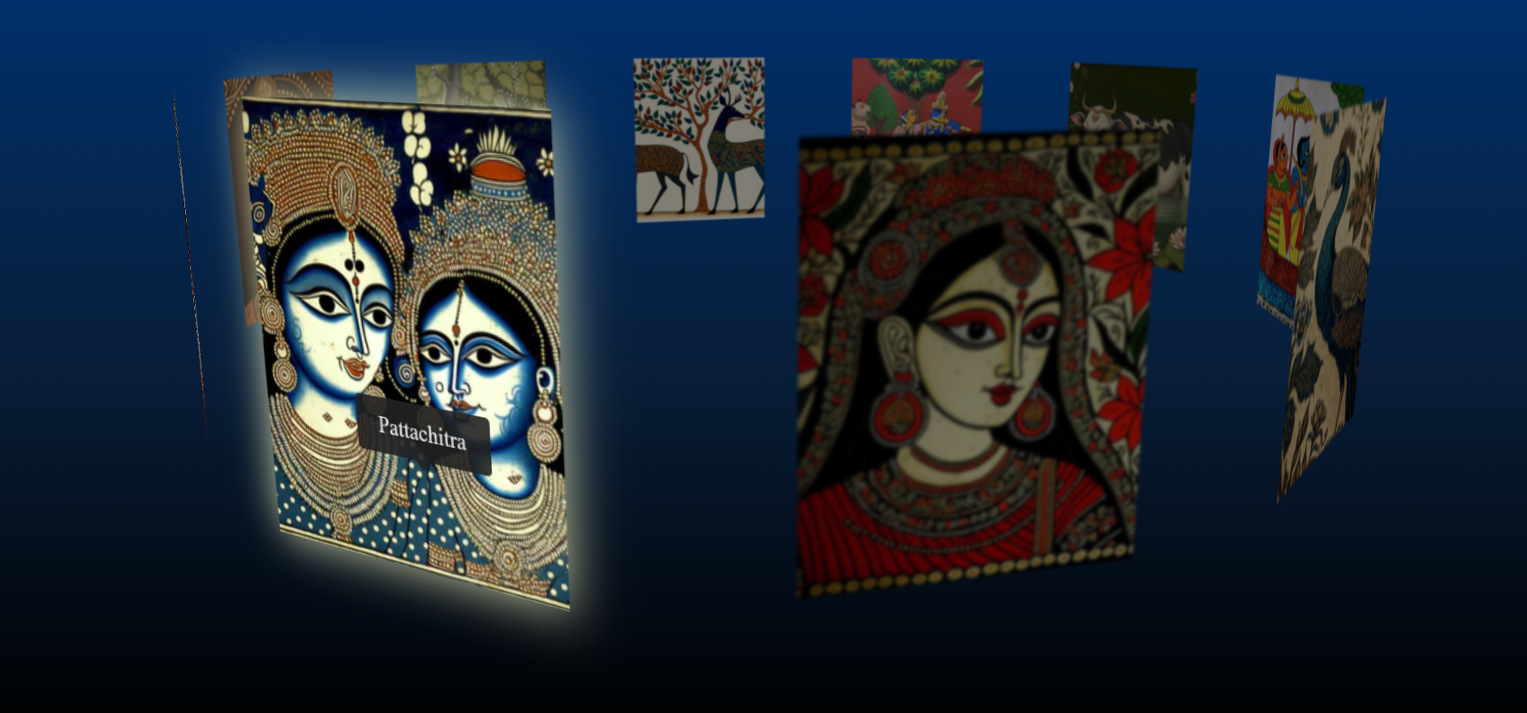

- The carousel has following animations:
- When it first opens
- It rotates
- On hovering over the image

- Click the image to open a modal with its description.
- Opening and closing of the modal has animation.
- Then inside modal, click on the image to zoom it.
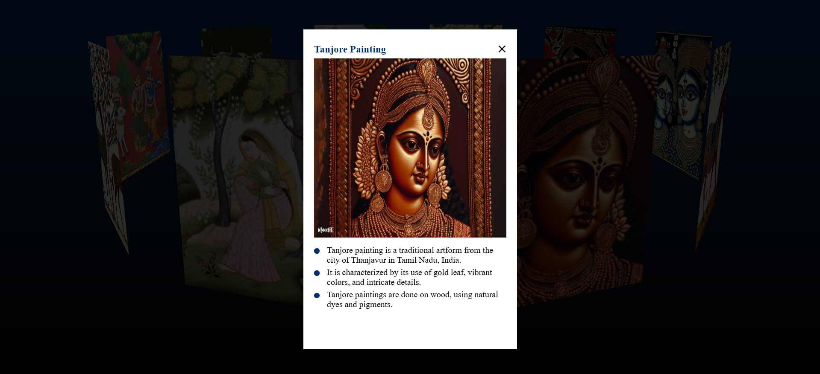
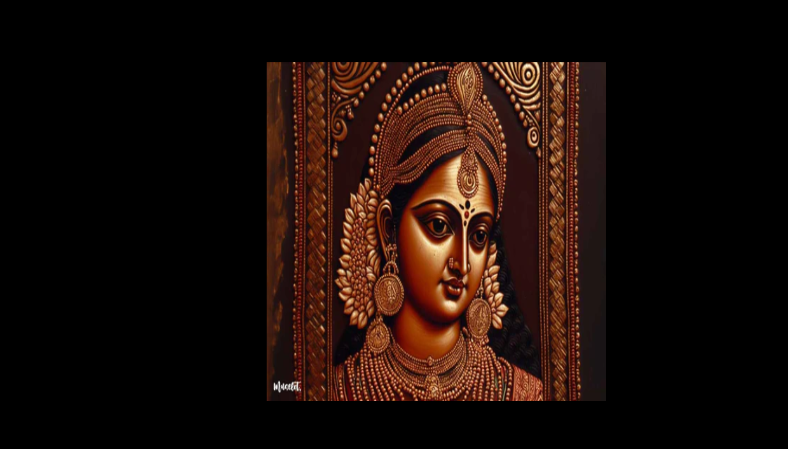

- Inside the zoom-modal click on the image to close it.
Resize the screen to check the responsiveness of the application.

